You may not be able to cure your toddler's cold, but you sure can offer some cold relief. Here's how to ease her sniffles and suffering.
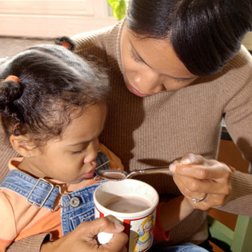
It starts innocently enough — with a sneeze here and a cough there. You try to ignore the telltale signs, but before you know it, your toddler’s nose is running, her throat is sore, and her forehead is burning up. There’s no denying when she’s got a cold — and once she has it, there’s no turning back. Whether you’re ready or not, you’re in for some tough days and sleepless nights.
Unfortunately, there is no cure for the common cold — only the passage of time, which tends to drag when your child is sick. For most kids, the worst of the cold passes after three or four days, but some symptoms can linger for ten days or beyond. In the meantime, you can offer some cold relief to your sniffling tot.
Feed her right. Scientists have proven what grandmothers have always known: Chicken soup can help relieve cold symptoms. Researchers say that the blend of nutrients in chicken soup may have an anti-inflammatory effect, which can ease swelling in the upper respiratory tract and relieve soreness in the throat. Plus, the warm broth (and its soothing steamy vapors) loosens the mucus that causes congestion. If that’s not enough, the salty soup helps prevent dehydration. If you don’t have any chicken soup handy, any type of warm broth may also help ease congestion.
What if your tot won’t eat? Don’t stress. Loss of appetite is normal when kids get colds, and it won’t cause any long-term harm. But do make sure your toddler gets enough liquids to prevent dehydration.
Focus on liquids. Speaking of fluids, don’t stop at soup. Make sure your child gets plenty to drink when she’s fighting a cold, be it water, juice, or even Popsicles. What about milk? While some people believe milk promotes the formation of mucus, most evidence shows that’s not true. So if your child wants milk, it’s probably a good way to get some liquid and calories into her. After all, it’s important to prevent dehydration in any way you can when your toddler is sick because she may lose extra fluids through sweating, and if she’s not eating well she’ll be missing the fluid contained in foods.
Help her breathe. As you well know, stuffy noses can be very uncomfortable, and they can keep your sick toddler from getting the sleep she desperately needs. To alleviate congestion, run a cool-mist humidifier (which is safer than a warm-mist humidifier should your toddler toddle too close to it) in her bedroom at night. Another good option: Try using saline nose drops to soften up crusty mucus in her nasal passages. If your toddler still has trouble sleeping, prop up her head with a pillow beneath the mattress.
Ease the fever. There’s no need to medicate every fever that comes along; a fever simply lets you know the body is waging war against an infection. But sometimes a little relief can help your child get the sleep she needs. For a low-grade fever (a fever of 103°F or higher in a child older than six months warrants a call to the doctor) give her ibuprofen (note that ibuprofen is approved only for children older than six months). Read the label carefully to make sure you give a dose that’s right for your child’s age and weight. One pain reliever to avoid: aspirin, because when given to kids, it can cause Reye’s syndrome, a serious illness.
Don’t ask for antibiotics. Don’t be tempted to push your doctor for antibiotics to treat the cold, either. Antibiotics won’t help (colds are caused by viruses, not bacteria) and the overuse of antibiotics is contributing to the growth of superbugs (bacterium that are resistant to treatment). So skip the meds and offer your toddler some extra TLC instead.

