Hello!
My name is Jawaria.
I am 10 and a half years old!
I have only one brother and two sisters.
Hobbies!
I love dancing, because it makes me happy I enjoy Math’s
Because I like working with 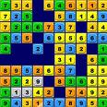numbers, and is great fun!
I also enjoy playing football because I always score.
What I am looking forwards to!
Is to meet different people and make friends, learn
Different languages and visiting places.
I am also looking forward to hopefully visiting the blue

