31.3.20 Answers
Red:

- 2$\frac{2}{6}$ = 2$\frac{1}{3}$ 2) 4$\frac{2}{8}$ = 4$\frac{1}{4}$ 3) 3$\frac{3}{12}$ = 3$\frac{1}{4}$ 4)4$\frac{4}{5}$ 5) 4$\frac{2}{9}$

Yellow:
- 4$\frac{2}{3}$ 2) 3+ $\frac{9}{8}$ = 4$\frac{1}{8}$ 3) 12+$\frac{16}{5}$ = 15$\frac{1}{5}$ 4) 10+ $\frac{10}{7}$ = 11 $\frac{3}{7}$

5) 12 + $\frac{3}{3}$ = 13 6) 15 + $\frac{35}{8}$ = 19 $\frac{3}{8}$ 7) 56 + $\frac{21}{8}$ = 58 $\frac{5}{8}$

8) 24 + $\frac{30}{9}$ = 27 $\frac{3}{9}$ = 27 $\frac{1}{3}$

Green:
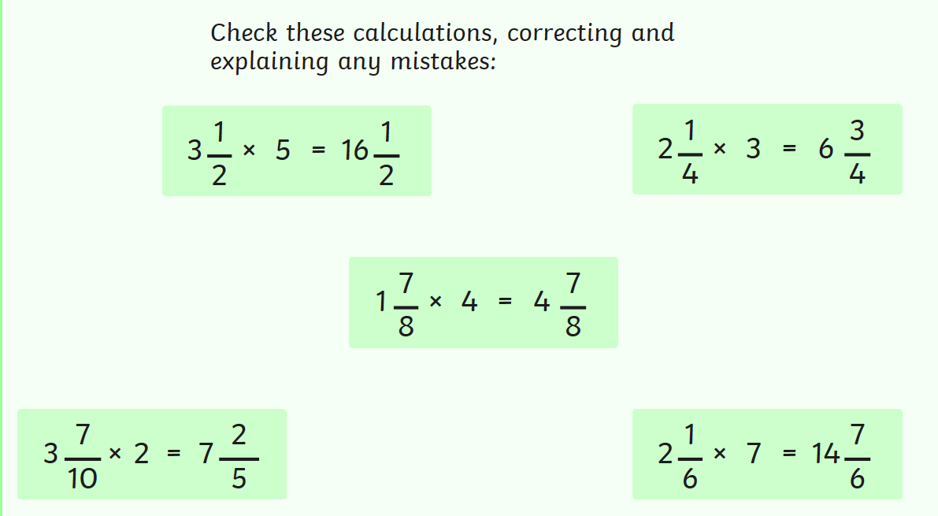

- 3$\frac{1}{2}$ x 5 = 15 + 2$\frac{1}{2}$ = 17$\frac{1}{2}$

- 2$\frac{1}{4}$ x 3 = 6$\frac{3}{4}$

- 1$\frac{7}{8}$ x 4 = 4 + $\frac{28}{8}$ = 7$\frac{4}{8}$ = 7$\frac{1}{2}$

- 3$\frac{7}{10}$ x 2 = 6 + $\frac{14}{10}$ = 7$\frac{4}{10}$ = 7$\frac{2}{5}$

- 2$\frac{1}{6}$ x 7 = 14$\frac{7}{6}$ = 15$\frac{1}{6}$

