Red:

- 1$\frac{1}{6}$ x 2 = 2) 2 $\frac{1}{8}$ x 2 = 3) 1$\frac{1}{12}$ x 3 = 4) 1$\frac{1}{5}$ x 4= 5) $2\frac{1}{9}$ x 2 =

Yellow:
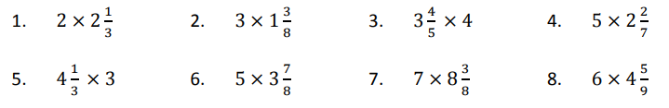

Green:
