Week beginning Monday 20th April
Dear Year 3
We hope you are all well and getting on ok at home. It’s quite hard having to stay at home and not visit people isn’t it.
Here is your work for another week at home.

Reading (Listen to a chapter each day)
The Boy Who Grew Dragons by Andy Shepherd
Monday
https://www.youtube.com/watch?v=aVxH51SYl9o Meet the author

https://www.youtube.com/watch?v=o0j62rufBHg chapter 1
Tuesday
https://www.youtube.com/watch?v=3xHKmnN8GZs chapter 2
Wednesday and Thursday
https://www.youtube.com/watch?v=EwLdWs5bYrM chapters 3 and 4
Friday
https://www.youtube.com/watch?v=5ciPEslD-vU dragon poem

Maths
Continue with the White Rose Maths doing a lesson each day.
Don’t forget your times table practise and building up our score on Times Table Rock Stars….we’re not doing too well at the moment……come on year 3, let’s show them who the best year group is!

Art
How to draw a dragon
https://www.google.com/search?rlz=1C1GCEB_enGB865GB865&biw=1707&bih=821&ei=6myUXvaVDJOy8gKDlZawAw&q=how+to+draw+a+cartoon+dragon+art+hub&oq=how+to+draw+a+cartoon+dragon&gs_lcp=CgZwc3ktYWIQARgBMgQIABBHMgQIABBHMgQIABBHMgQIABBHMgQIABBHMgQIABBHMgQIABBHMgQIABBHSgkIFxIFMTItMjBKCAgYEgQxMi0yUABYAGDrSWgAcAJ4AIABAIgBAJIBAJgBAKoBB2d3cy13aXo&sclient=psy-ab#kpvalbx=_9GyUXu2hO86X8gKE6bSIAw47

Science
We’re going on a visit to Longleat Safari Park, as we tour around the park make a list of all the animals you see.
https://www.youtube.com/watch?v=pUmHClrRPxc
Once you’ve done your tour choose an animal you’d like to find more out about. Do some research of your own. Think about where in the world the animal would normally live, what it likes to eat, what conditions does it normally live in, what its young are called, how long it is expected to live for and any other interesting facts you can find. Make yourself a fact file.

Topic
Find out what clothes people wore in Roman times. Use your research to help you make an outfit of your own using thigs you can find at home. Take some photos and email them to us so we can see what you looked like as a Roman. Happy dressing up!

Writing
This week, as you can see, a panda has been in school and got up to all sorts of mischief. We’ve started the story off for you and each day we’d like you to write another chapter of the story so by the end of the week you’ve told us all the things the panda might have got up to. You can also draw some pictures of the things the panda did to go with your story. We wonder what naughty things the panda might get up to? Happy writing (and drawing!)

The Panda Who Came to School
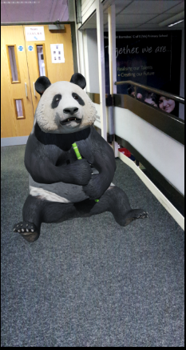
Chapter 1

It was just like any other Monday as I arrived at school, until I came to the front entrance. There, sat right in the middle of the ramp was a giant panda chewing on a piece of bamboo. He wasn’t making any noise or fuss; he was just sitting minding his own business. No one knew where he had come from or how he had got into school. Everyone was in agreement that he had to go and quickly!
“Please will you move from the ramp?” asked Mrs Smith in a friendly voice.
The panda just stared at her and kept chewing his bamboo.
“We really need you to move as the children will be arriving soon,” added Mrs Mason politely.
The panda just stared at her and kept chewing his bamboo.
“Panda, move right now or we’ll have to call the police!” shouted Mr Suleman.
The panda just kept staring and chewing his bamboo.
Next Mr Collins tried to persuade the panda to move, then Miss Marshall. Hearing all the fuss Miss Bailey came out of Reception and whispered in the panda’s ear. But still the panda stared and chewed.
At that moment Talha from 3CS arrived at school.
“Hello Mr Panda do you want to come to see my classroom?” asked Talha with a glint in his eye.
After a moment or two the panda peered at Talha. He stopped chewing his bamboo. Slowly the panda got to his feet and followed Talha to his classroom.
“This is going to be the best day ever,” thought Talha.
Little did he know what mischief the panda had in mind for his visit to school.

Chapter 2
The Panda who came to the classroom

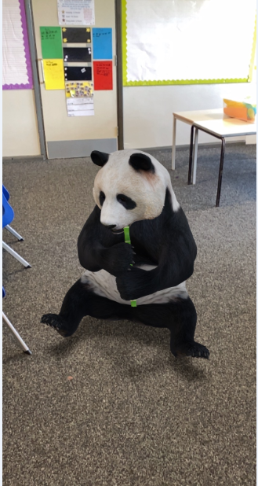

Chapter 3
The Panda who came to the hall
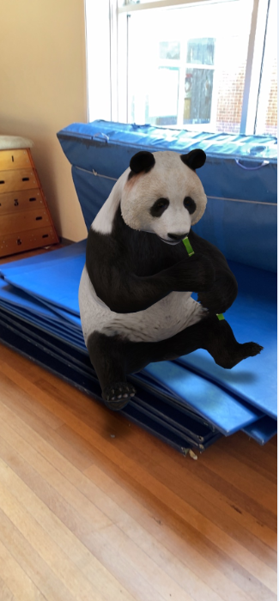

Chapter 4
The Panda who came to the playground
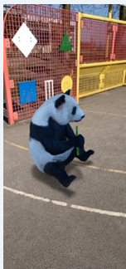

Chapter 4
The Panda who came to the office
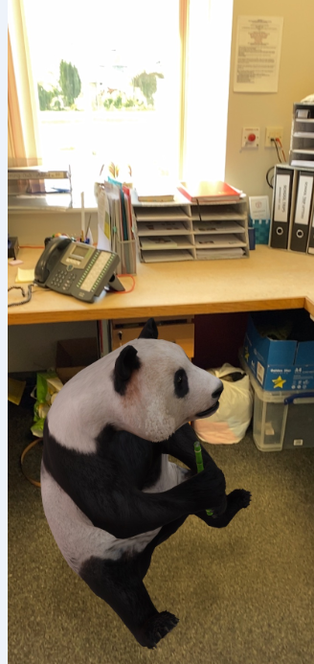

Chapter 5
The Panda who took over the school!
