Maths work

In addition to completing the White Rose maths lessons https://whiterosemaths.com/homelearning/year-1/ try out one of these games each week.
They are from the NRICH website.

Game 1
https://nrich.maths.org/10654
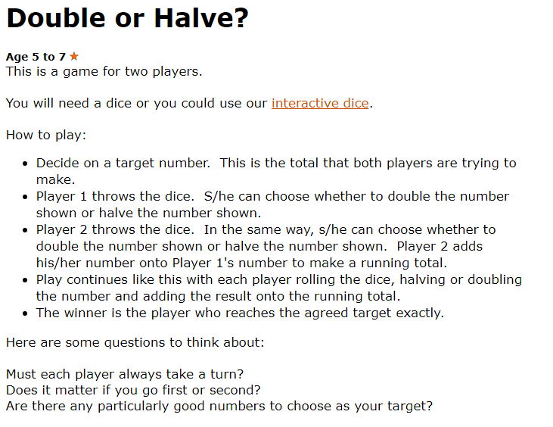

Game 2
https://nrich.maths.org/6074
Shut the box
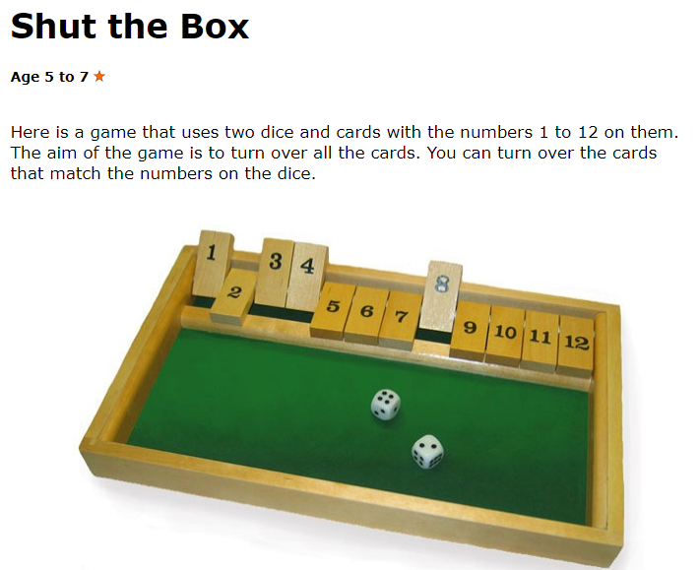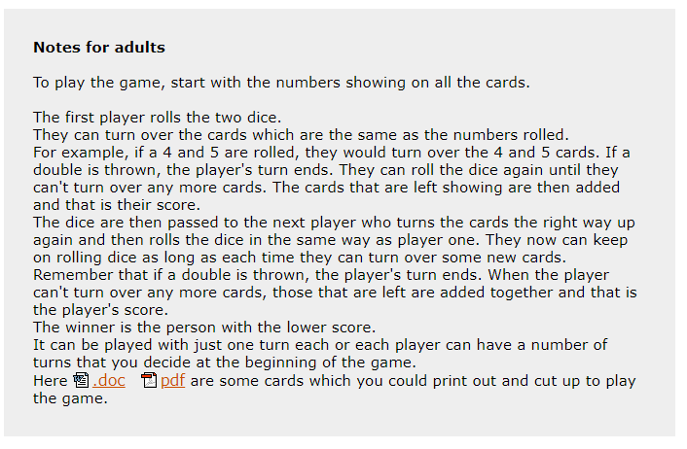You can just make your own number cards from 1-12 or write your own number line and cross them out.
Game 3
https://nrich.maths.org/1247
Pass the peas please
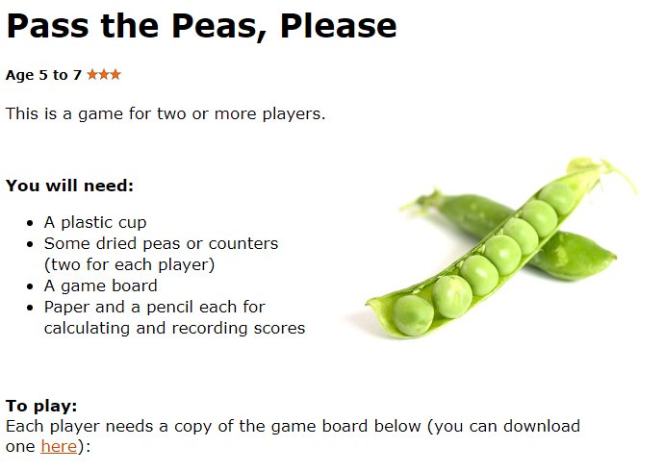
Or you can copy the grid and write the numbers in yourself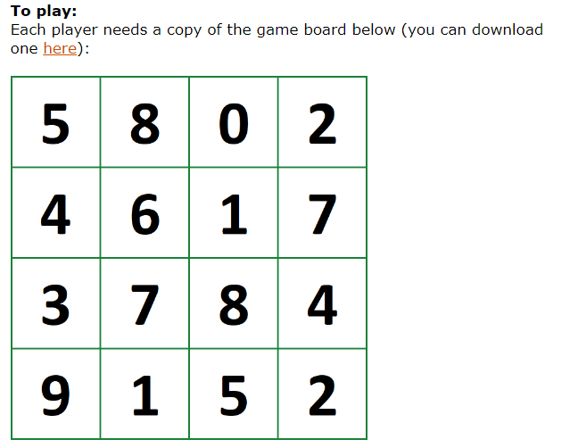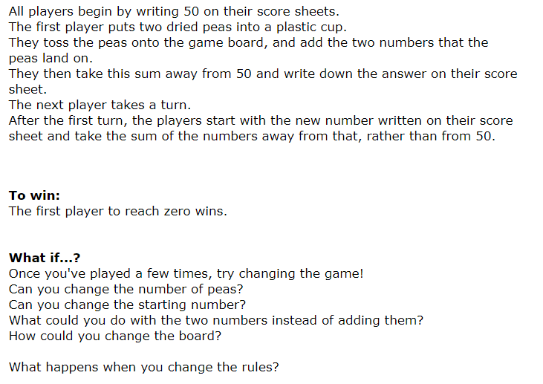
Game 4
https://nrich.maths.org/10091
Strike it out
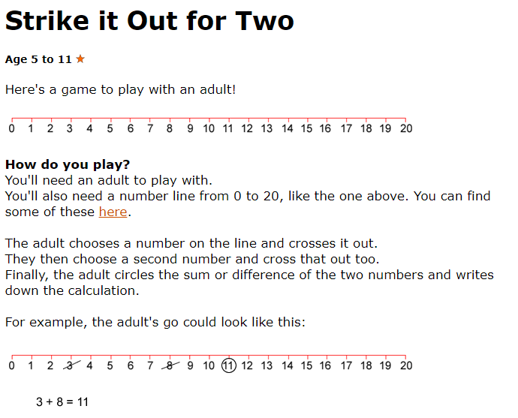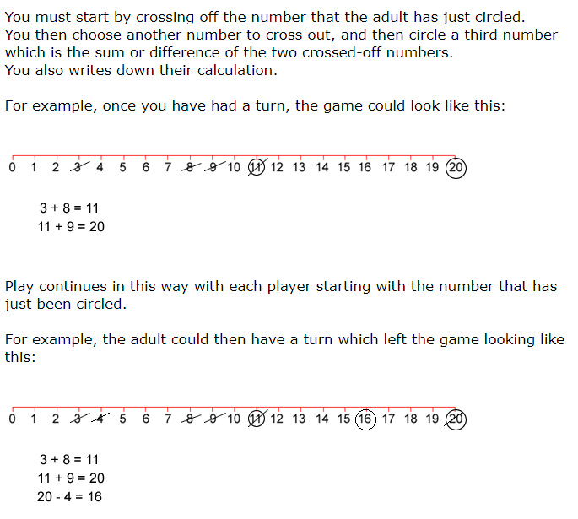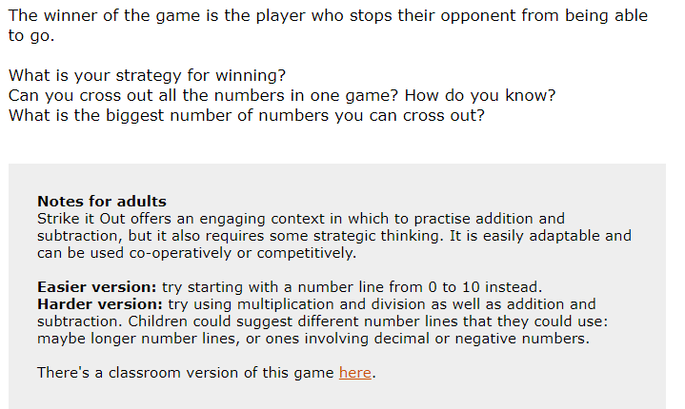
Game 5
https://nrich.maths.org/10092
Dotty 6
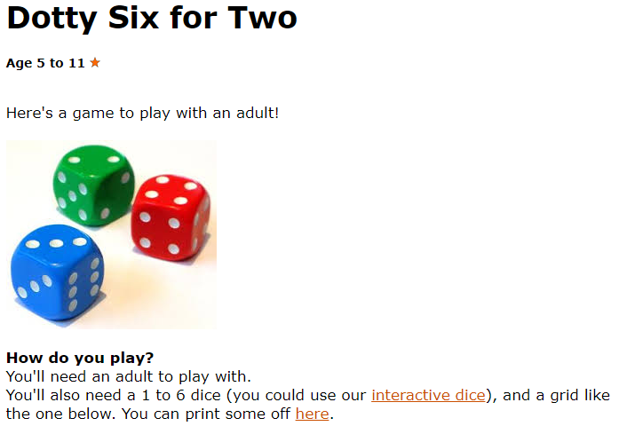
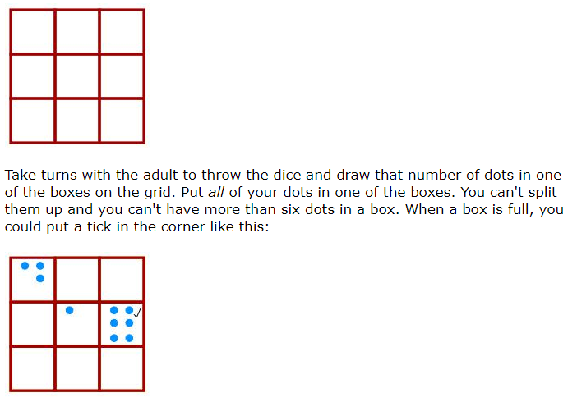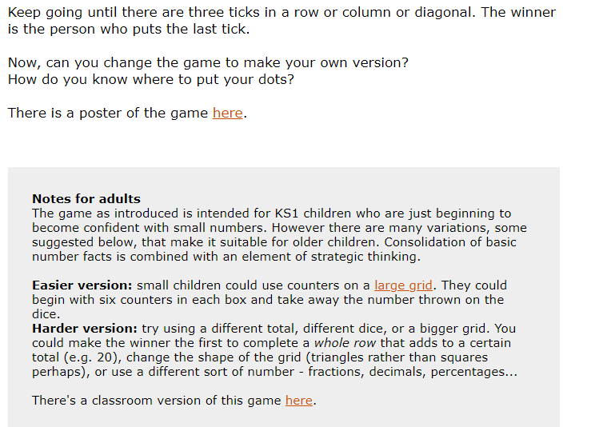

Game 6
https://nrich.maths.org/1204
Nim-7

Nim-7

Age 5 to 14
This is a basic form of the ancient game of Nim.
You will need seven objects, such as counters or blocks. It is a game for two players.
Place the 7 counters in a pile and decide who will go first. (In the next game, the other player will have the first turn.)
Each player takes turns to take away either one or two counters.
The player who takes the last counter wins.
Keep playing until you work out a winning strategy.
Does it matter who has the first turn?
What happens when you start the game with more counters?

