Year 5 home learning – week
Hello,
Don’t worry if you have just found these lessons online. Please follow the planning on our website in week order – start on week 1 and 2 then progress through.

Week 5
You will have heard the government have released a national online school with work to help children when home schooling - Oak National Academy. I would suggest that children do the Maths, English and foundation lessons on this site. The foundation lessons include science, history, languages (Spanish – which is the language that year 4 children in school have begun to learn) and music as an example. Each lesson has a video that talks children through what they are learning and worksheets which you can either print off or do the work in a book / on paper. In addition, there is usually a start and end quiz so that you and your child can see what they have learnt. We have been doing the lessons at home.
https://www.thenational.academy/online-classroom/year-4#schedule

Week 1 | Maths | English | Foundation
Monday | Area and perimeter | Poetry: reading comprehension - word meaning. | Henry VIII
Tuesday | Area and perimeter | Poetry: reading comprehension - language. | Spanish: alphabet and numbers.
Wednesday | Area and perimeter | Features of poetry | What is light and where does it come from?
Thursday | Area and perimeter | Expanded noun phrases | Henry VIII lesson 2
Friday | Area and perimeter | Poetry: write a repetitive poem. | Music: pulse

Spelling and handwriting:
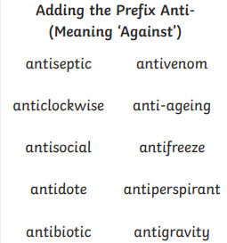
Please also see the handwriting and spelling activity sheets.

Please also practice spelling the common excepted words.

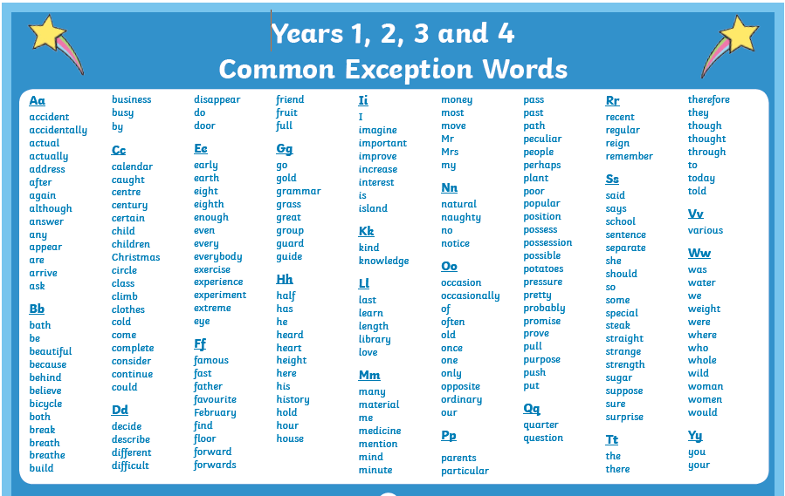

Other useful English:
Please go to the BBC bitesize lessons for year 4.
https://www.bbc.co.uk/bitesize/tags/z63tt39/year-4-and-p5-lessons/1
20th April – Pronouns
22nd April – Past tense verbs and verb families

Geography:
Please go to the BBC bitesize lessons for year 4.
https://www.bbc.co.uk/bitesize/tags/z63tt39/year-4-and-p5-lessons/1
21st April – Geography, Maps
28Th April – Geography, Contours, keys and sybols
When you have done these two lessons you could make your own map of a walk that you do or print out a map and follow it when you go out for a walk. You could also look for a map o the internet of Bradford and see how many places you can find that you have been to. Can you find school, your house, a local place of worship? What else can you find?

Has anybody enrolled with Bradford libraries to borrow free ebooks? If not please look at last week’s letter which will tell you how to enrol and read books online. Also remember that there are a wide range of children’s books on the Oxford Owl site below. We use lots of these books in school. There are a wide range of levelled phonics books as well as fact and fiction books which are levelled to meet the needs of individual children.
https://home.oxfordowl.co.uk/books/free-ebooks/#

Don’t forget the PE sessions with Joe Wicks, Monday to Friday at 9am on his YouTube channel. If you
miss the live session you can catch up anytime throughout the day.

If you need any further support, please contact school through schoolclosure@hstb.co.uk
and someone will get back to you when they are able to. Please write the class teachers name on the email.

Best wishes and stay safe,
Mrs Day, Mrs Horsley and Mrs Mason.

