Galileo Galilei
Galileo was a brilliant scientist, mathematician and astronomer. His scientific observations and inventions changed the way people thought about the world and his ideas and discoveries are still hugely relevant today. However, because of his scientific findings, his life was not always an easy one.
Galileo Galilei was born on 15th February 1564 in Pisa, Italy where he grew up with his brothers and sisters. His father, who was not a particularly wealthy man, was a famous musician and music teacher. At around the age of 10, Galileo and
his family moved to Florence where Galileo went to school at Camaldolese monastery. He was a talented musician and a very able student. Learning in a monastery, at first Galileo believed that he would become a priest, but his father did not want him to pursue a career in religion and removed him from the school. In 1581, he studied medicine at the University of Pisa, training to become a doctor.
Galileo was always curious about the world around him and he shifted the focus of his university studies to mathematics. In 1585, he left university without earning a degree and got a job as a professor. At this time, he continued to study mathematics on his own and started to perform scientific experiments.

The Tower of Pisa
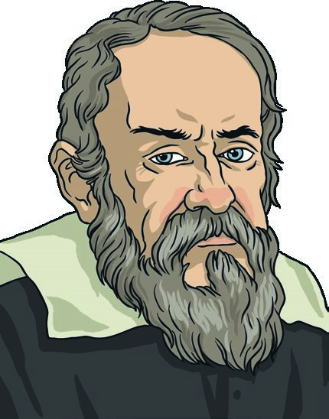
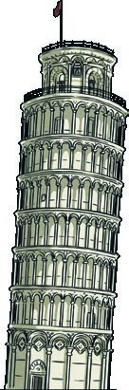
One famous experiment was the Tower of Pisa experiment. At that time, a commonly held belief was that if two objects were dropped from the same height, the heavier one would land first. To test this theory, Galileo went to the top of the Leaning Tower of Pisa and dropped two balls of different weights. They both landed at the same time and Galileo had thereby invalidated the original theory.

Galileo Galilei

Telescope
In 1609, Galileo heard about an invention by Hans Lippershey that could make things that were far away appear much closer. This invention was the telescope. Galileo was fascinated and began to build his own version of the optical instrument. His improvements were so good that he was able to use it to view the Sun and other planets in space. This led to major discoveries, including that Jupiter was orbited by four moons and that the moon was covered in craters as opposed to being smooth.

Controversial Ideas
Another belief that Galileo did not just accept was that the Sun orbited the Earth. In the 1500s, an astronomer called Copernicus came up with the idea that the Sun was at the centre of the universe, not the Earth as people had previously believed. Galileo studied Copernicus’ work and felt that his scientific observations supported his idea. In 1632, Galileo published his findings in a book called ‘Dialogue of the Two Principal Systems of the World’.
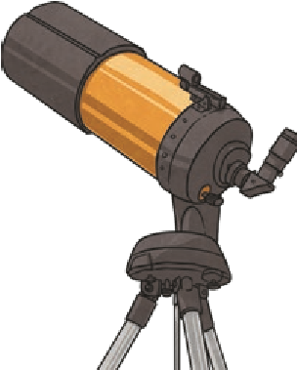
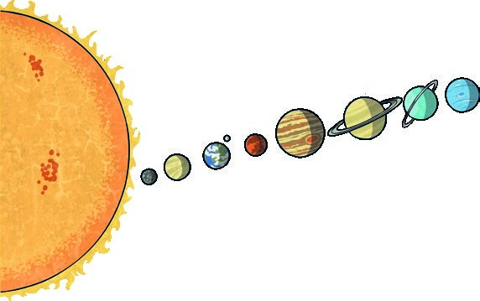
Galileo’s ideas and findings were not popular at the time as they went against people’s traditional beliefs about the world. Galileo was forbidden by the Catholic church to write or teach about his work and was sentenced to life in prison for heresy (challenging religious beliefs). However, his sentence was later changed, and he was permitted to live under house arrest. Galileo continued to study and a year before he died, he came up with a pendulum design that could be used for keeping time.
Galileo became blind in his older years. He died in Florence on 8th January, 1642.

Did You Know...?
In 1979, the Catholic church and Pope John Paul II investigated how Galileo had been treated. 13 years later, the Pope made a formal apology and finally admitted that his, and the ideas of Copernicus, were actually correct.

Questions

- Where was Galileo born? Tick one.
Florence
Paris
Pisa
Rome
- What did Galileo do at Camaldolese monastery?

- Explain why Galileo's father removed him from Camaldolese monastery.

- Where did Galileo train to become a doctor? Tick one.
University of Florence
Camaldolese monastery
University of Rome
University of Pisa
- Find and copy a word which means disproved.

- Explain why Galileo was so fascinated by Hans Lippershey's invention.

- Which planet did Galileo discover four moons orbiting?

- Explain in your own words what heresy means.

- Do you think that Galileo was treated fairly? Explain your answer.

