History Activity: Focus on Florence Nightingale
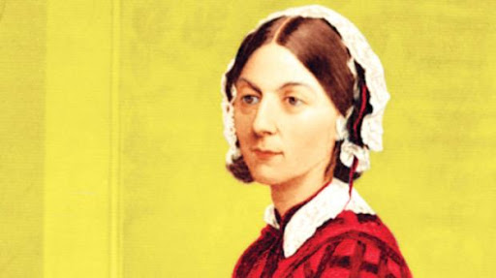
You need to do as much reading and research about Florence Nightingale as possible and then present what you have learned in whatever form you wish.

Try listening to this radio programme from BBC Radio 4 for lots of interesting facts (Search on BBC iPlayer for Homeschool History Florence Nightingale): https://www.bbc.co.uk/sounds/play/m000jfy8
Or you could search for Horrible Histories videos on youtube. https://www.youtube.com/watch?v=Ho6JC146Z8Y
https://www.youtube.com/watch?v=u5pSbe-9bNQ
Or look at other fact files about her and videos on the BBC https://www.bbc.co.uk/teach/class-clips-video/history-ks1-ks2-florence-nightingale/z68fcqt

You could create a scratch project on her, do a powerpoint presentation with a quiz, create a poster and take a photo of it to share with us, video yourself presenting a report on her… the possibilities are endless.

