Hello Year 2

We hope you’ve had a great week! Here is the work for this week and remember if you want to send us any photos or videos of anything you’ve done you can send it to schoolclosure@hstb.co.uk .
Keep checking purple mash for new work set there every week and remember to hand it in so we all see what you’ve completed.
https://www.purplemash.com/login/

Maths
Please carry on with your work on Face, Shapes and Patterns on the Oak Academy website.
https://www.thenational.academy/online-classroom/year-2/maths#subjects

You can also carry on your shape learning with BBC Bitesize.
https://www.bbc.co.uk/bitesize/topics/zjv39j6/articles/ztpwdmn

Reading
You can continue to read at home and if you are running out of stories use the oxford owl website to find a new favourite.
https://www.oxfordowl.co.uk/for-home/find-a-book/library-page/

English - Instructions

Look at the lessons on instructions for year 2 on Oak Academy. There are 5 lessons to complete over the week

https://www.thenational.academy/year-2/english/the-firework-makers-daughter-to-retrieve-information-year-2-wk1-1

Spellings
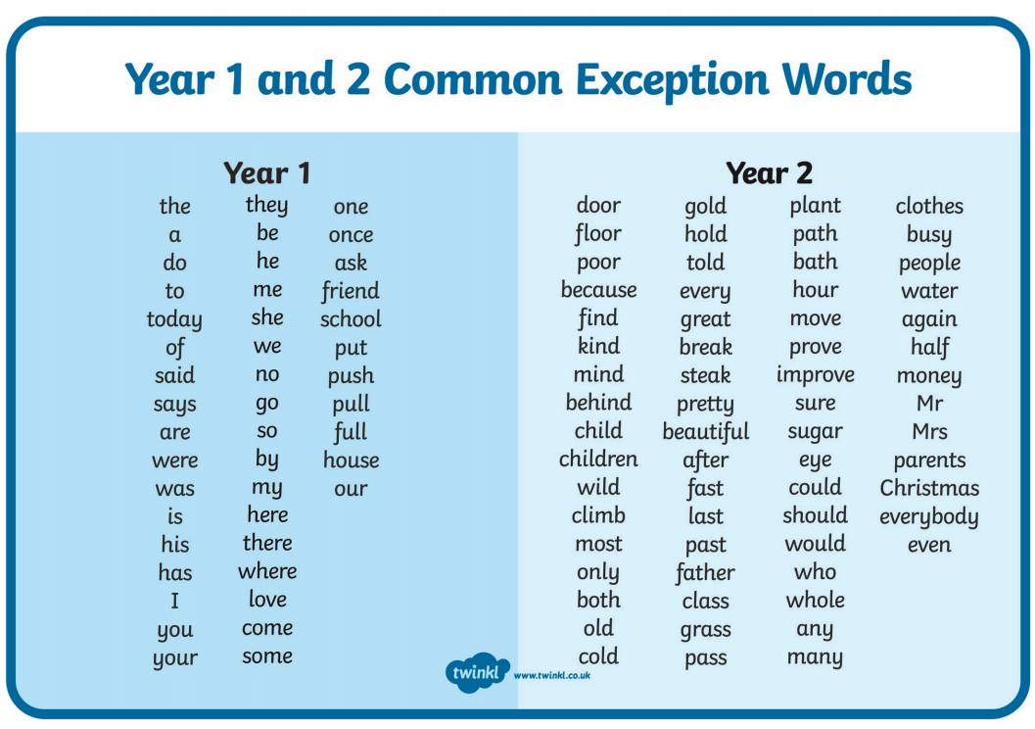
Please continue to practice the common exception words at home. This week’s spellings test words are.

wild
fast
could
Christmas
climb
last
should
everybody
most
past

Science - Basic parts of a plant

Can you name the different parts of a plant?
How should we look after plants?
Find out all you can about the different parts of a plant and if you have plants in your house or in the garden, perhaps you could look after them this week.
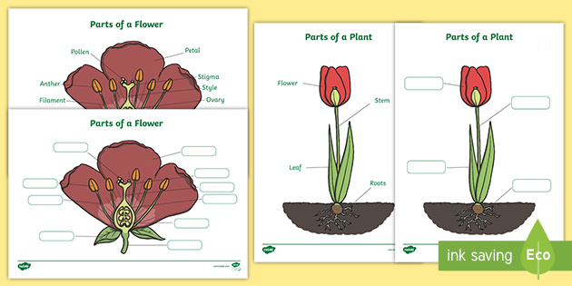

https://www.bbc.co.uk/bitesize/articles/zrh8wty
https://www.twinkl.co.uk/resource/T-T-043-Parts-of-a-plant-foundation

Stay safe and see you all soon.
From
Mr Clark and Miss Sharp

