Hello Year 2,

Hope you’ve all had a great week!

If you haven’t already done so, remember to take a look at the daily lessons on BBC Bitesize for year 2. The lessons cover a number of subjects including maths, english, history, geography and music.
https://www.bbc.co.uk/bitesize/tags/z7s22sg/year-2-lessons/1

Maths:
Please continue to use the white rose home learning videos for Summer Term week 3 and complete the work that is linked to the lessons. First watch the video, then do the worksheet either by printing it out or in a book. Then check your answers using the answer sheet given. Please use the website link below.
https://whiterosemaths.com/homelearning/year-2/

Oxford owl free ebooks
https://www.oxfordowl.co.uk/for-home/find-a-book/library-page/

Spelling and handwriting:
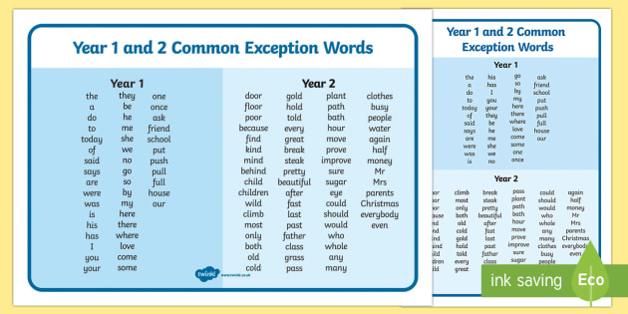
Please focus on these spellings this week
kind steak
break improve
prove money
half behind
mind pretty

V E Day 2020

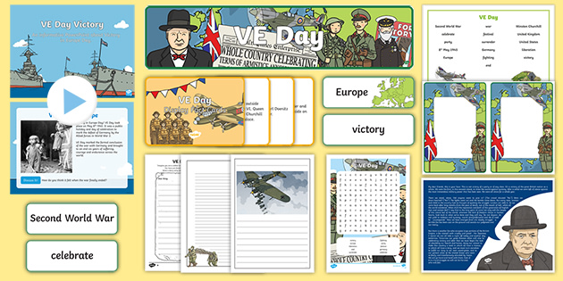

- With the V E Day celebrations this week and the bank holiday on Friday, what can you find out about V E Day? Do some research and then write about what you have found out. How was the day celebrated in 1945? Draw a picture to go with your writing.

- Prepare a wartime dish from the recipe ideas on twinkl. Will it be pear crumble or eggless sponge?
https://www.twinkl.co.uk/resource/t2-h-4750-wartime-recipe-booklet

- Design a V E Day medal.

- Make special bunting to display in your windows on V E Day.

If you need any further support, please contact school through schoolclosure@hstb.co.uk
and someone will get back to you when they are able to. Please write the class teachers name on the email.

Stay safe
,
Miss Sharp and Mr Clark

