HSTB Reception VE DAY challenges

Monday 4th May

Hello RM and RB,

On Friday it is VE Day and we are celebrating this day because 75 years ago WW2 came to an end. The war was a sad time beacuase different countries were fighting with each other. The men from this country went to war whilst the women and children stayed at home. When the men left home, the women had many new jobs to complete that they weren’t allowed to do before! Even the Queen trained to be a mechanic. The cities became a very dangerous place and the children were evacuated to the countryside to keep safe.

CHALLENGE ONE:

What happened to your family during WW2? You could ask your grandparents or great grandparents. Did anyone fight in the war, were they evacuated or did they learn a new job? Can you write a sentence about your family?

CHALLENGE TWO:

Look at a map of the United Kingdom. Can you find England, Scotland, Ireland and Wales on the map? Create your own Union Jack to wave on Friday.

Don’t forget to upload your work to the EExAT app so we can see it and comment.

I hope you enjoy learning about your family,

Miss Marshall and Miss Bailey

Tuesday 5th May

Good morning, today we will continue with our VE Day activities.

CHALLENGE ONE:

Today we will be listening to some songs sung during WW2. How does the song make you feel? Do you think these songs would have helped the soldiers? Are they happy or sad songs?

https://www.youtube.com/watch?v=77IHUYpeEyY&list=PLxyvoSWOzbGZ3goBZ7AYy5sUqWojaa9o9&index=25

CHALLENGE TWO:

During the war there was not a lot of food. The government introduced rationing. This meant that you could only buy a small amount of food but it also meant that everyone would get food.

Today we are going to ration your food at home. Eachsnack and meal will cost a certain amount of money e.g breakfast 10p, banan 5p, crisps 20p…but you will only have £1 to spend all day. When you have used up all your money you will not be able to buy any more food.

*Grown-ups the aim of this activity is for children to recognise the value of different coins. You may wish to do some work on this first e.g hide them around the room to ensure recognition, look at the value (x2 5p’s are the same as 10p…remind children of their number bonds to 5 and 10)*

We look forward to seeing your pictures!

Miss Marshall and Miss Bailey

Wednesday 6th May

Good morning,

CHALLENGE ONE:

Look at the picture below. What can you see? How do they feel? What are they doing? What would you be doing? Write a sentence about the picture.

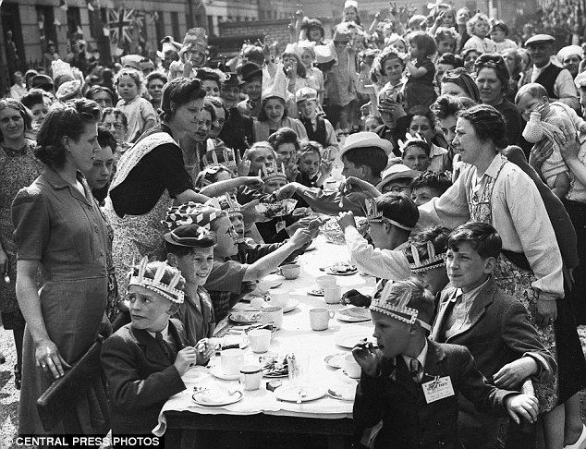

CHALLENGE TWO:

To celebrate VE Day people created decorations such as bunting to decorate their homes. Can you make some bunting or other decorations for your home to celebrate VE day?

Well done,

Miss Marshall and Miss Bailey
Thursday 7th May

Good morning,

To celebrate VE day the whole country had a party! Today we are going to complete activities to prepare for a party.

CHALLENGE ONE:

We have attached some war time recipes below. Please choose one to make.

CHALLENGE TWO:

Write a list of other food or decorations you will need for the party.

Tomorrow is a holiday for the whole country, maybe you could have a tea party with all your wonderful decorations and food you have made? Don’t forget to upload any pictures to the EExAT app so we can see all the fun you’ve had and comment!

A huge thank you for all your effort this week,

Miss Marshall and Miss Bailey

(Recipes are on the following pages)

Potato scones

Ingredients
225g mashed potato
22g flour
Pinch of salt
½ teaspoon baking powder
Milk
1 tablespoon oil

Method
- Mix the potato, flour, salt and baking powder together with enough milk to make a stiff paste.
- Roll out about 5mm thick
- Fry the first cake in a little oil, the others will do without
- Butter and serve hot in a pile!

Carrot buns

Ingredients
225g self-rasing flour
75g margarine or cooking fat
75g sugar
4 tablespoons finely grated raw carrot
2 tablespoons sultanas (optional)
1 egg
Little milk or water

Method
- Preheat the oven to 220c – gas mark 7
- Grease 2 baking trays
- Sift the flour into a mixing bowl
- Rub in the margarine/fat
- Add the sugar, carrots, sultanas and egg
- Mix well then add enough milk/water to make a sticky consistency
- Put 12 small heaps on the baking trays
- Cook for 12-15 mins or until firm and golden in colour

Bread pudding

Ingredients
225g stale bread
50g margarine or butter
25g sugar
1 tablespoon marmalade
50g dried fruit
1 egg
Milk to mix
Ground cinnamon

Method
- Pre-heat the oven to 180c or gas mark 4
- Put the bread into a bowl, add cold water and leave for 15mins. Then squeeze dry with your fingers
- Crumble the bread into a bowl
- Add all the other ingredients and enough milk to make a sticky consistency
- Add a pinch of cinnamon
- Spoon into a greased tin (20cm, 8”) and bake in the centre of the oven for 1 hour
- Remove from the oven and allow to cool for 10 mins
- Serve warm or cold

Golden slices

Ingredients
Stale bread
2 eggs
1 heaped teaspoon of grated orange or lemon peel
1 table spoon of orange juice
Margarine or oil

Method
- Cut the pieces of bread ½ inch thick
- Beat the eggs in a bowl and add the grated peel and orange juice
- Soak the stale bread in the mixture
- Fry in a little margarine or oil until golden brown on both sides
- Sprinkle with sugar if you have it
- Serve hot

ENJOY!

