Hello Year 2

Lots of news around about schools at the moment but it does mean that Year 2 will still be learning from home. We hope the ideas this week help you keep busy and learning lots. And remember if you want to send us any photos or videos of anything you’ve done you can send it to [schoolclosure@hstb.co.uk](mailto:schoolclosure@hstb.co.uk) .

Keep checking purple mash for new work set there every week and remember to hand it in so we all see what you’ve completed.

<https://www.purplemash.com/login/>

**Maths**

This week moving on from shape we will be looking at position and rotation. Lots of use of language with plenty of ways to make this practical at home following your work on instructions in English last week. Here are two websites to support this learning and check Purple Mash for extra activities on this as well.

<https://app.mymaths.co.uk/253-lesson/position-and-turning>

<https://www.thenational.academy/year-2/maths/to-describe-the-position-of-an-object-year-2-wk2-3>

**Reading**

You can continue to read at home and if you are running out of stories use the oxford owl website to find a new favourite.

<https://www.oxfordowl.co.uk/for-home/find-a-book/library-page/>

You may also like the stories read to you on BBC Iplayer here is Tom Hardy reading The problem with Problems.

<https://www.bbc.co.uk/iplayer/episode/m000hs1y/cbeebies-bedtime-stories-753-tom-hardy-the-problem-with-problems>

**English – Grammar**

Let’s keep those writing skills going in preparation for year 3 and practice our grammar skills. Here are a few lessons to follow along with and practice some prefixes and suffixes

<https://www.bbc.co.uk/bitesize/topics/z8mxrwx>

**Spellings**

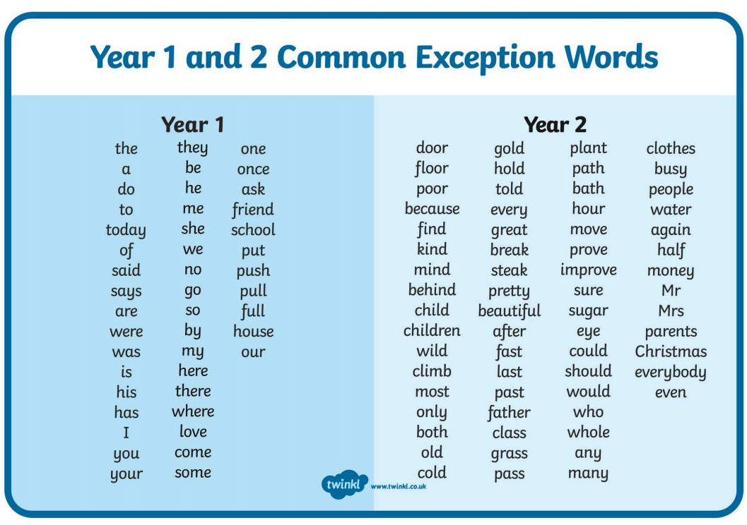

Please continue to practice the common exception words at home. This week’s spellings test words are.

would

even

only

father

who

both

class

whole

old

grass

Foundation

Art

As the weather continues to improve and we are allowed outside more. Take a chance to explore the art work of Andy Goldsworthy. Follow this lesson online to find out more about outdoor art.

<https://www.thenational.academy/year-2/foundation/to-investigate-the-colours-year-2-wk1-5>

Stay safe and see you all soon.

From

Mr Clark and Miss Sharp