Year Writing Competition
Choose from one of these three exciting choices of our writing competition with a chance to win a special delivery to the house. Use paragraphs, direct speech and quality sentences with different openers. Your story should be no more than 500 words. The closing entry date is Friday 15th May 2020. Make sure you email them to office@hstb.co.uk for a chance to win.
Choice 1
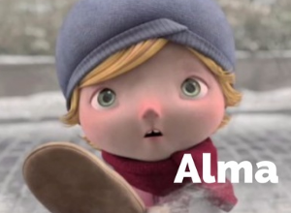
Alma is a little girl who ventures into town in the snow. She is drawn to a shop window by a familiar looking doll. She enters the shop... what will happen when she goes inside?
Watch the story of Alma on the link below and write the story. Can you make it sound as spooky as it really is?
https://www.literacyshed.com/alma.html
Choice 2
The Arctic Circle animation. In a desolate landscape one man's survival depends on the single fruit tree by his abode. One day a strange box arrives and gives him a special power. Will he be able to control his urge to keep the box from his neighbour?
Watch the link below and write the story in 3rd person/1st person narrative or write a sequel - what happens when his neighbour finds the box - perhaps he is less greedy.
https://www.literacyshed.com/arctic-circle.html
Choice 3
Choose one of the following story starters and create your own story.
- I didn’t mean to kill her.
- The air turned black all around me.
- Icy fingers gripped my arm in the darkness.
- Wandering through the graveyard it felt like something was watching me.
- The eyes in the painting follow him down the corridor.
- A shrill cry echoed in the mist
- Icy wind slashed at his face and the rain danced its evil dance upon his head as he tried to get his bearings on the isolated beach.
- Footsteps slowly creaked on every step of the stairs. The bedroom door handle turned slowly.
- Death lurked in every door way with hell at one dark window. My hair stood on end, a shiver raced down my spine and a lump came to my throat. It was him...
- Slowly, a foot moved, then the trunk, then a loud growl shook the cavern...
Remember, no more than 500 words – Good luck!

