Week commencing 01.06.20

Dear Year 3,

I hope you all are having a great time in this beautiful weather. Here are some home learning tasks for you all to complete this week. Please try to do these and email any pictures of your work that you would like to show your teacher.

**Maths**

Log in to My Maths and type year 3. Have a go at the addition and subtraction lessons. In addition to this, there are a range of work set out for you in Purple Mash and My Maths that you can complete. If you are having problems logging on please ask an adult to call the school so we can help you with logging on. Also, don’t forget to practise your times tables on TT Rockstars.

**English**

For your writing this week can you make up and write your own episode of your favourite programme? Maybe you like episodes of Horrid Henry, Pokemon, or Odd Squad. Whatever it may be, this is your chance to get creative and write about something you already enjoy! Can you write your own episode of your chosen programme? Remember to make it exciting so that it is enjoyable to read. Try using different sentence openers, adverbials, expanded noun phrases, speech marks, capital letters and full stops. Don’t forget to check and edit your work before you are finished.

**Reading**

J.K. Rowling fans can read her brand new story online before it is published! I have no idea what an Ickabog is but I’m intrigued to find out so will be reading this too. Each week there will be a new chapter or two available for you to read over several weeks. Just log on to the website shown below to read the first chapter!

<http://theickabog.com>

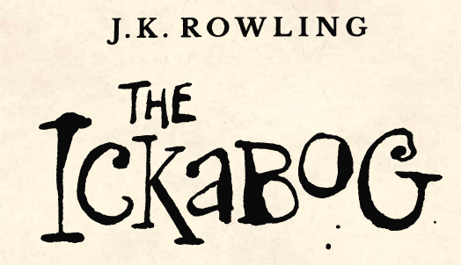

**Art**

You can also enter an illustration competition for The Ickabog, just click on the link on the above web page for more details. Winners will have their pictures featured in the book once it is published. Why not send in a picture to us at school too? These can be sent to the school’s email address and will be forwarded to your teacher at: **schoolclosure@hstb.co.uk**

**Science and D&T**

We had started to learn about nutrition and food groups in school. For science, research what the different food groups are. Can you draw a circle and show how much of each food group we should be eating? Which different foods are in each food group? Can you list or draw them? You can also plan and draw a plate of your healthy meal making sure you have the right proportion of the different food groups.

If you like helping in the kitchen, why not help the adults at home to cook a nice healthy balanced meal? What would you make? Don’t forget to send in any pictures of your home learning activities!

**Spellings** – please ensure you are practising some of these words each day.

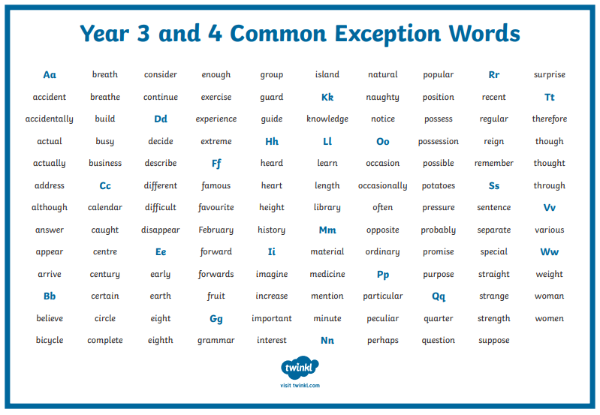

Finally a big well done to Hadi in 3J for doing the home learning activities each week. He has sent in some pictures of the fantastic work he’s been doing at home. Keep up the good work Hadi! If you would like to email your pictures to your teacher please send to: **schoolclosure@hstb.co.uk**

That’s all for this week. Try to make the most of the lovely sunshine we’re having at the moment, ride a bike, or go for a walk or run or spend some time playing in the garden. Hope you all have a great week.

Miss Juneja