Year 6 home learning – week
Hello everyone,
We are missing you lots and cannot wait to see you all again. Please send us an email to tell us the things that you have been up to during the week. What have you been doing for exercise? Have you had time to do any crafts? Are you doing anything special for V.E. day on Friday? We have made some bunting in red, white and blue and are going to be wearing red, white and blue all day. We are also going to have afternoon tea (sandwiches and buns) at the same time as our neighbours a bit like a party but at a distance.

**Please look for the challenge that has been set below in Spanish.**
*Please look at the idea on how to get a Blue Peter badge.*

Week
I would suggest that children do the Maths, English and foundation lessons on Oak National Academy, the government site. The foundation lessons include science, history, languages (Spanish – which is the language that year 4 children in school have begun to learn) and music as an example. Each lesson has a video that talks children through what they are learning and worksheets which you can either print off or do the work in a book / on paper. In addition, there is usually a start and end quiz so that you and your child can see what they have learnt. We have been doing the lessons at home.
https://www.thenational.academy/online-classroom/year-4#schedule

Week 2 | Maths | English | Foundation | P.E.
Monday | Area part 1 - estimating | Story: reading comprehension - word meaning. | Henry VIII Lesson 3 | P.E. with Joe Wicks
Tuesday | Area part 2 - Calculating | Story: reading comprehension – Fact retrieval | Spanish: Introducing yourself to Spanish | P.E. with Joe Wicks
Wednesday | Area part 3 – cm2 | Story – Identifying the features of a text | What is light and how do we use it? | P.E. with Joe Wicks
Thursday | Area part 4 – mm2 | SPAG focus – expanded noun phrases. | Henry VIII lesson 4 | P.E. with Joe Wicks
Friday | Area part 5 – application. | Story – continue a story. | Music: to beatbox using rhythmic patterns. | P.E. with Joe Wicks

Extra challenges for Spanish –
Why not try to learn Spanish that would help you when you are in a town and city?
Here are some links to help you.
https://www.youtube.com/watch?v=48ji0U0PfUE
https://www.youtube.com/watch?v=VLbHOuazmIM
https://www.youtube.com/watch?v=b-bo_y0lMqE
https://www.youtube.com/watch?v=DCSu5QKQWIE
You could then draw or make a collage of places you see near where you live and label it. Why not tell someone in your family or on a video call about your picture using the Spanish vocabulary you have used. You could even email it to your teacher so that we can share it with others.

Spelling and handwriting:
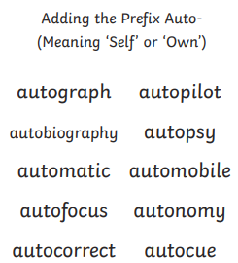
Please also see the handwriting and spelling activity sheets.

Please also practice spelling the common excepted words.

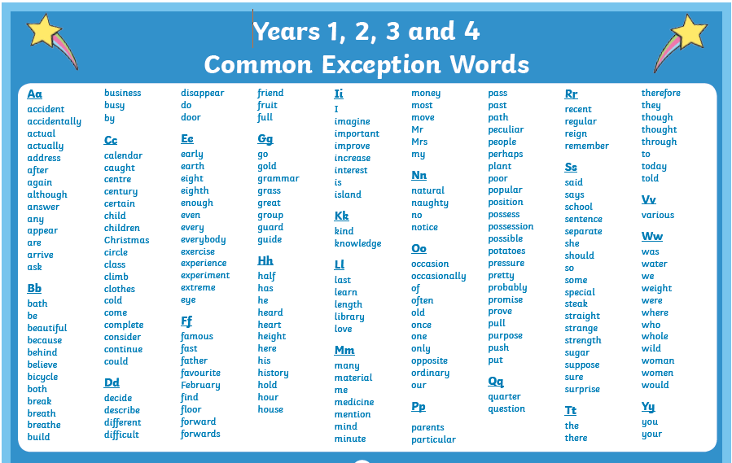

Other useful English:
Please go to the BBC bitesize lessons for year 4.
https://www.bbc.co.uk/bitesize/tags/z63tt39/year-4-and-p5-lessons/1
23rd April – Adverbs ad adverbial phrases
27th April – Identifying and using prepositions.
Geography:
Please go to the BBC bitesize lessons for year 4.
https://www.bbc.co.uk/bitesize/tags/z63tt39/year-4-and-p5-lessons/1
28th April – Time Zones
When you have done this lesson you could find out about Counries that you know and find out what tie zone they are in.

Science:
https://www.bbc.co.uk/bitesize/tags/z63tt39/year-4-and-p5-lessons/1
29th April – States of matter

Don’t forget that there are a wide range of children’s books on the Oxford Owl site below. We use lots of these books in school. There are a wide range of levelled phonics books as well as fact and fiction books which are levelled to meet the needs of individual children.
https://home.oxfordowl.co.uk/books/free-ebooks/#

Can get a Blue Peter badge?
Have you ever watched Blue Peter? Would you like a Blue Peter badge? There are now lots of different Blue Peter Badges to be awarded.
There are now 8 different badges that you can apply for. Here are a few I thought you might be interested in.
Blue – for sending in interesting letters, stories, pictures, poems, ideas for the show etc.
Green – Based around environmental activities.
Fan Club - if you join the Blue Peter Fan Club.
Music – For learning a new instrument or being part of a musical performance.
Sport – For trying a new sport that you have never tried before.

Why not go to the Blue Peter Website and see if you would like to apply for a Blue Peter Badge. Please Email and let us know if you get a badge.
https://www.bbc.co.uk/cbbc/joinin/about-blue-peter-badges

If you need any further support, please contact school through schoolclosure@hstb.co.uk
and someone will get back to you when they are able to. Please write the class teachers name on the email.

Best wishes and stay safe,
Mrs Day, Mrs Horsley and Mrs Mason.

