Year 4 home learning – week 7

Hello everyone,
This week we have a varied package of home learning activities to keep you engaged. Please have a look through the things below and see how many activities you can do. If you find any different things that you have enjoyed using to help your learning and you think that your friends at school would also enjoy please let us know.

Oak National Academy, the government site has lots of super work on and the lessons for maths and English will really help you when you come back to school.
https://www.thenational.academy/online-classroom/year-4#schedule

Please note that there are now assemblies and Faith at home sessions on the website that your child may wish to access.

Week 3 | Maths - measurements | English – News report | Foundation | P.E.
Monday | Choosing appropriate measures. | News report: reading comprehension – fact retrieval. | History: Henry VIII’s great matter lesson 5. | P.E. with Joe Wicks
Tuesday | Converting between mm and cm. | News report: reading comprehension –inference. | Spanish: Saying your birthday in Spanish. | P.E. with Joe Wicks
Wednesday | Converting between cm and m. | News report – Identifying the features of a text. | Science: What is refraction and how can we use it? | P.E. with Joe Wicks
Thursday | Capacity and mass. | News report, SPAG focus – inverted commas. | History: The Spanish Armada lesson 1. | P.E. with Joe Wicks
Friday | Solving measures problems. | News report – write a news report. | Music: sing a major scale, | P.E. with Joe Wicks

Maths
Hopefully you got on well with the Oak National Academy activities last week. This week in maths we would like you to have a go at the measurement lessons.
Additionally, we have set some MyMaths work for children to complete and then submit online. This supports the work on measures and also practises basic number facts. Please encourage your children to access these materials and also to complete any practical measurement activities at home to support further. Please note, children in year 4 are at different learning points and it is fine for your child to just complete the activities appropriate to their learning stage. The MyMaths activities are differentiated, with activities being set for different pupils so therefore this should all be at your child’s learning level. Any queries or concerns, or for password support, please contact school using the usual telephone number or schoolclosure@hstb.co.uk using the classteacher’s name as a reference.

English
We hope you enjoyed the lessons on Oak academy looking at stories. This week the lessons are about News reports. We will be building on these when we get back to school so please have a go at them. There are also some lessons on the BBCbitesize webbpage that will help with your learning.
Please go to the BBC bitesize lessons for year 4.
https://www.bbc.co.uk/bitesize/tags/z63tt39/year-4-and-p5-lessons/1
30th April – Inverted commas for speech.
28th April – Apostrophies to combine words.
29th April – Apostrophies to show possession.

Reading
Don’t forget to read the children’s newspaper – First News that is on the website.
Remember to spend time each day reading. You could read to find out more about something you have been learning about e.g. Henry VIII, science and refraction, countries around the world, Ramadan around the world or to enjoy a story.
If you have read all of your books at home or just want a change remember that there are a wide range of children’s books on the Oxford Owl site below. We use lots of these books in school. There are a wide range of levelled phonics books as well as fact and fiction books which are levelled to meet the needs of individual children.
https://home.oxfordowl.co.uk/books/free-ebooks/#
Also you can use the Bradford library website to enrol and get an ebook to read.

Spelling and handwriting:
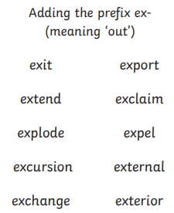
Please also see the handwriting and spelling activity sheets.

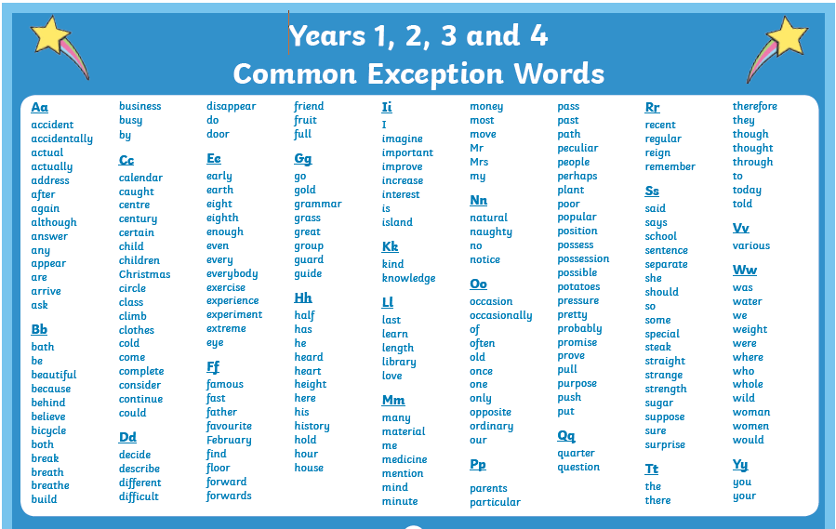
Please also practice spelling the common excepted words.

Geography:
Please go to the BBC bitesize lessons for year 4.
https://www.bbc.co.uk/bitesize/tags/z63tt39/year-4-and-p5-lessons/1
28th April – Time Zones
5th May – Time Zones
When you have done these lessons you could find out about Countries that you know and find out which time zone they are in.

Science
Year 4 are keen scientists, so in order to keep those skills sharp we would like you to have a go at some experiments using the https://www.britishscienceassociation.org/news/new-home-based-activity-packs-launched materials. Once there, click on the SuperStar home-learning resource and you will find lots of different experiments for Key Stage 2. This week we would recommend trying the Crafty Rafts and Bridge Blunder activities – these are similar to experiments we have completed in class and we had great fun at home competing against each other to make the strongest bridge and raft. Send photos of your experiments to schoolclosure@hstb.co.uk so we can see what you have been getting up to!

Extra challenges for Spanish –
Last week we gave you the extra challenge of learning Spanish words that would be useful when you are in a town and city?
Here are the useful links to help you.
https://www.youtube.com/watch?v=48ji0U0PfUE
https://www.youtube.com/watch?v=VLbHOuazmIM
https://www.youtube.com/watch?v=b-bo_y0lMqE
https://www.youtube.com/watch?v=DCSu5QKQWIE
We then gave you a selection of activities to do:
Draw or make a collage of places you see near where you live and label it.
Tell someone in your family or on a video call about your picture using the Spanish vocabulary you have used.
Finish the above if you have not done them already then try to complete the sheet of Spanish activities. Try to practice using the vocabulary when you are out doing your daily exercise. Talk about the things that you see in Spanish. You could also make a model or map of a pretend town centre and use Spanish vocabulary to talk about the places you have made. You could make a video to teach someone else the Spanish vocabulary that you have learnt.

Please email some of your work to us.

If you need any further support, please contact school through schoolclosure@hstb.co.uk
and someone will get back to you when they are able to. Please write the class teachers name on the email.

Best wishes and stay safe,
Mrs Day, Mrs Horsley and Mrs Mason.

