Year 4 home learning – week 8

Hello to each and every one of you,
It has been lovely to have emails or talk to lots of you this week. We have enjoyed hearing all about the work that you have been doing at home as well as the crafts plus activities that you have been doing outside. Lots of you have been making the most of the lovely weather and time with your family which is so nice to hear.
After talking to parents we have decided to put together a simpler range of activities here and extra work on Purple Mash and MyMaths that children can do in addition to extend their learning.

The main lessons will be using Oak National Academy (the government site) as it is easy for children to follow with the videos. The most important learning that your child can do each week is reading at least 4 times a week, practice the spellings that we give as well as the maths and English lessons on Oak Academy.
https://www.thenational.academy/online-classroom/year-4#schedule
Please note that there are now assemblies and Faith at home sessions on the website that your child may wish to access.

Week 4 | Maths - measurements | English – News report | Foundation | P.E.
Monday | Measures: Time, marathon training. | Persuasion: reading comprehension, Fact retrieval. | History: The Spanish Armada lesson 2. | P.E. with Joe Wicks
Tuesday | Measures: The price of stamps. | Persuasion: reading comprehension –summary. | Spanish: How to say the date in Spanish. | P.E. with Joe Wicks
Wednesday | Measures: Ribbon riddle. | Persuasion : Identifying the features of a text. | Science: How we see light. | P.E. with Joe Wicks
Thursday | Measures: Money, coin purse challenge. | Persuasion: SPAG focus – imperative and modal verbs. | History: The Spanish Armada lesson 3. | P.E. with Joe Wicks
Friday | Measures: Mixed measure problems. | Persuasion: write a persuasive rap. | Art: Texture treasure hunt. | P.E. with Joe Wicks

Reading
Don’t forget to read the children’s newspaper – First News that is on the website.
Remember to spend time each day reading. You could read to find out more about something you have been learning about e.g. Henry VIII, science and light or to enjoy a story.
I have put a couple of reading comprehensions onto the website as a couple of parents said they preferred to print these out for their children.
Remember there are a wide range of children’s books on the Oxford Owl site below. We use lots of these books in school. There are a wide range of levelled phonics books as well as fact and fiction books which for different abilities to meet the needs of individual children.
https://home.oxfordowl.co.uk/books/free-ebooks/#

Spelling and handwriting:
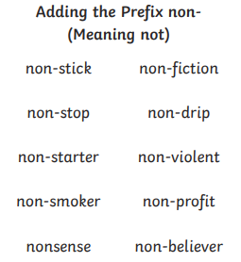
Please also see the handwriting and spelling activity sheets.
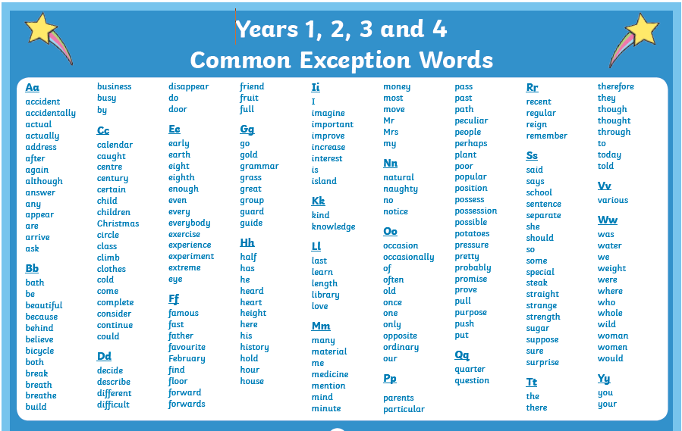
Please also practice spelling the common excepted words.

English
Please go to the BBC bitesize lessons for extra year 4learning.
https://www.bbc.co.uk/bitesize/tags/z63tt39/year-4-and-p5-lessons/1
4th May – Using paragraphs correctly.
5th May – Exploring fronted adverbials.
6th May – Coordingating conjunctions.
12th May – Using similies and metaphores.

Work we have put on platforms that we would like the children to do:
Purple Mash – spellings and phonics for selected children.
My Maths – activities related to the maths on Oak National Academy.

We have also been getting passwords to you for MyMaths accounts that we have just set up. If you have not received yours yet we will get them to you as soon as possible. There are a couple of parents who we have not had an email back from or spoken to on the phone. Please get in touch so that we can get passwords to you. Please contact school through schoolclosure@hstb.co.uk writing the class teachers name on the email.

Don’t forget to email and let us know what you have been doing as well as photos of your work.

Best wishes and stay safe,
Mrs Day, Mrs Horsley and Mrs Mason.

