June 1st 2020
Hello Year 2

We are now entering June and what would be our final term in school. We would have finished our SATS by now and looking forward to a summer term full of outdoor learning and transitional activities to get us ready for the move to Year 3 and the beginning of KS2. But for now we are all still doing our best to keep safe and stay home. As always please keep checking purple mash for new work set there every week and remember to hand it in so we all see what you’ve completed.
https://www.purplemash.com/login/

Maths
As it does not seem that Year 2 will be coming back soon we have updated Mymaths and have created the secondary logins for each child. This allows us to set homework for children and track their progress. If you want to access this at home, please phone the school office on
01274 54019 or email us on schoolclosure@hstb.co.uk and ask for the mymaths log in.
New work will be set here each week so please keep checking.
You can of course keep using the website like you have been and choose your own work to complete.

Reading
You can continue to read at home and if you are running out of stories use the oxford owl website to find a new favourite.
https://www.oxfordowl.co.uk/for-home/find-a-book/library-page/

You may also like the stories read to you on BBC Iplayer here is Vicky Mcclure reading ‘goodnight little bot.
https://www.bbc.co.uk/iplayer/episode/m000hzwk/cbeebies-bedtime-stories-754-vicky-mcclure-goodnight-little-bot
There are also free resources out there that require an account to be made but can open a world of books when traditional libraries are closed.
Please search for https://openlibrary.org/ and sign up for free to borrow books just like you could from school or a library.
While schools are closed epic books are offering free access to their online library if you sign up https://www.getepic.com/

English – Grammar

This week we are asking you to learn about homophones and chosing which homophones to use and when. Please work through these 3 activities at your leisure throughout the week.
https://www.bbc.co.uk/bitesize/topics/zqhpk2p

Spellings
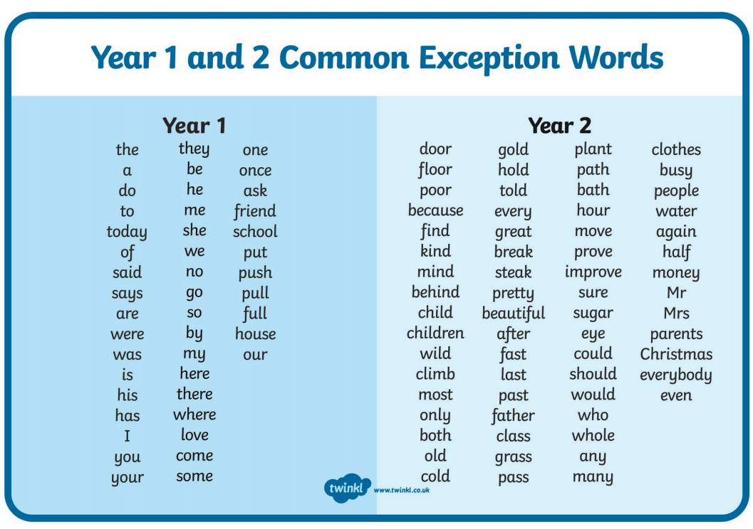
Please continue to practice the common exception words at home. This week’s spellings test words are.
Any
Cold
Pass
Many
Clothes
Busy
People
Water
Again
Half

Foundation
June 1st begins wildlife in your garden week. And the wildlife trust are setting the challenge to do something wild everyday this month. If you follow this link https://www.wildlifetrusts.org/ you can order a free pack to help encourage getting outside and discovering the wildlife on your doorstep.
And remember if you want to send us any photos or videos of anything you’ve done you can send it to schoolclosure@hstb.co.uk .

Stay safe and see you all soon.
From
Mr Clark and Miss Sharp

