Hello Year 2

We hope you are all well and keeping busy. It’s been almost 7 weeks and it’s great to see all the work you have been doing. If you want to send us any photos or videos of anything you’ve done you can send it to us schoolclosure@hstb.co.uk .
First of all keep checking purple mash for new work set there every week and remember to hand it in so we all see what you’ve completed.
https://www.purplemash.com/login/

Maths
On TTrockstars 2S are stretching their lead to over 12,000 questions answered. COME ON 2C!!
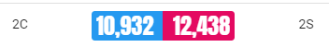
https://play.ttrockstars.com/

To carry on your maths this week we have some work on shape brought to you by the people at oak academy.
https://www.thenational.academy/year-2/maths/to-identify-shapes-by-the-number-of-sides-and-vertices-year-2-wk1-1#slide-2

Or you may want to learn about 3D shapes through Twinkl
https://www.twinkl.co.uk/resource/t-t-2548386-3d-shapes-picture-hotspots

Reading
You can continue to read at home and if you are running out of stories use the oxford owl website to find a new favourite.
https://www.oxfordowl.co.uk/for-home/find-a-book/library-page/

If you would rather someone read to you then David Walliams will be reading extracts of stories at 6pm on Sunday.
https://www.worldofdavidwalliams.com/watch-and-listen/
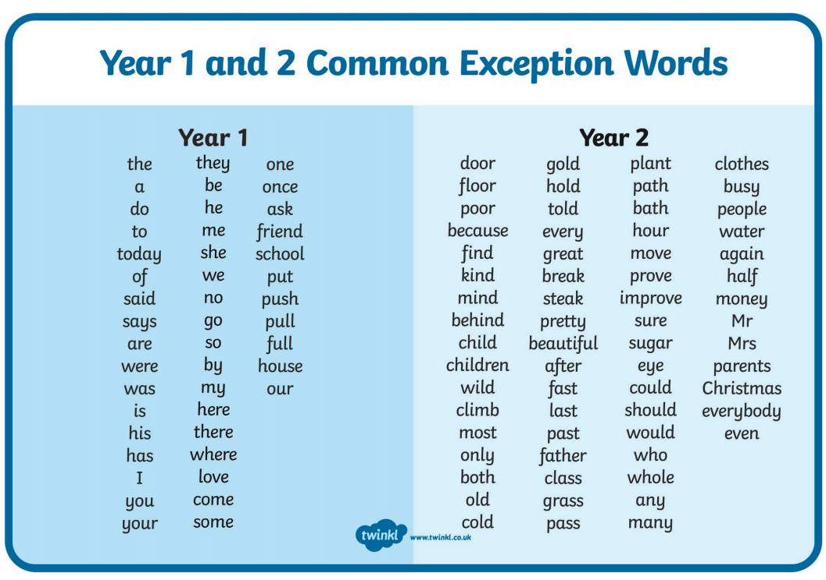
Please continue to practice the common exception words at home. This week’s spellings test words are.

Sure
Mr
Child
Beautiful
Sugar
Mrs
Children
After
Eye
Parents

This week on the 12th of May is national limerick day. This 5-line poem was made famous by the writer Edward Lear. Here you can see one of his first limericks. 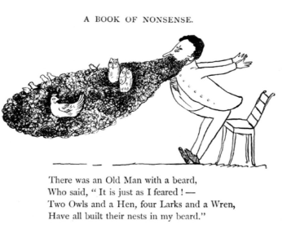

It would be wonderful this week to hear you read your limericks out loud so please use the planning sheets below to support you then record yourself reading it outloud and send it to schoolclosure@hstb.co.uk so we can all enjoy it. For a bit of inspiration you can watch Michael Palin reading some of his https://youtu.be/Q2E4wwSDBV4?t=109 by following this link.

Stay safe and see you all soon.
From
Mr Clark and Miss Sharp
