**Year 4 home learning – week 15 – 29.6.2020**



Hello. I have been challenging myself to read more at home. Instead of turning on the TV I have picked up a book, found somewhere comfortable to sit and read. I love reading.

How about you? Maybe you could try this

Join the ‘Silly Squad’ in this year’s Summer Reading Challenge

<https://summerreadingchallenge.org.uk/> and log in to discover awesomely funny books to read, play games and make friends. Running from June – September 2020.

Please encourage your children to complete the academic work added to the following sites.

**TT Rock Stars battle -** 4HM v 4D - Wed 8th July and Thurs 9th July at 17.00 to 18.00.

**Purple Mash**:

* **Maths** – A range of place value and number activities and games.
* **English** –Word Combos – Do you know the difference between a verb, a noun and an adjective?

**My Maths** - Place Value and Roman numerals.

**Read Theory** – Please continue the work on the Read Theory website. We have been so impressed with the children who are working through the comprehensions. We can see a huge improvement in their understanding already. Please contact school for your log in details.

Please continue to use **Oak National Academy** (the government site) as it is easy for children to follow with the videos. There are now assemblies and Faith at home sessions that you may wish to access.<https://www.thenational.academy/online-classroom/year-4#schedule>

|  |  |  |  |
| --- | --- | --- | --- |
| Week 10 | Maths - | English – | Foundation |
| Monday | To investigate the place value of different numbers. | Reading comprehension  Fact retrieval - Diary | George Floyd – Our catalyst for change. |
| Tuesday | To investigate Roman numerals up to 100 | Reading comprehension  Inference - Diary | Spanish – family members and pets. |
| Wednesday | To identify and complete number sequences. | To identify the key features of a diary. | What adaptations do nocturnal animals have? |
| Thursday | To investigate number patterns 1 | SPAG – expanded noun phrases and conjunctions. | What resources does the Uk have? |
| Friday | To investigate number pattern 2 | To write our own diary using the key features. | The circle challenge. |

**Read Theory Superstars**

Who has started to complete Read Theory this week?



**4HM - Sara, Eliza and Hisham – fantastic work. So glad you have joined us ☺**

**4D – Sehr, Sahil and Krish – Welcome and a big well done.**

**Class Blog**

Mrs Day and Mrs Horsley have been busy setting up Purple Mash blogs – one for 4D and another one for 4HM. Is there someone in your class you would like to say “Hi” to? Do you have some work you would like to show us or do you have a joke to share? We would love to hear from you.



**Spelling and handwriting:**

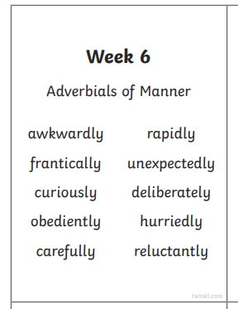

Please also see the handwriting and spelling activity sheets.

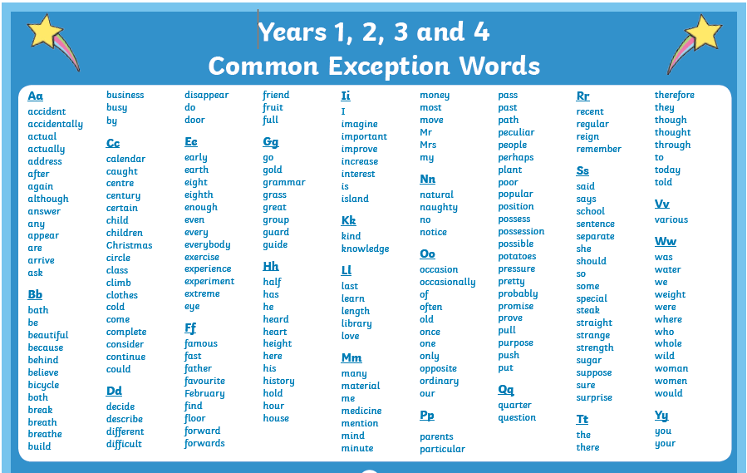

Please also practice spelling the common excepted words.

Please remember that your child should be reading at least 4 times a week, learning their times tables and practicing the spellings that we set.

If you have any queries regarding your child’s learning please email the teachers school email or contact school through [schoolclosure@hstb.co.uk](mailto:schoolclosure@hstb.co.uk) writing the class teachers name on the email.

Stay safe and keep smiling

Mrs Day, Mrs Horsley and Mrs Mason.