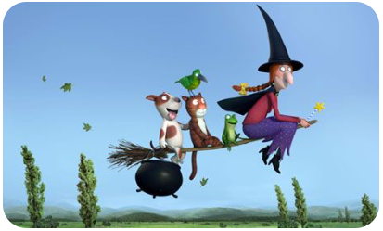
The characters in Room on the Broom act like a caring family because
………………………………………………………………………………………………………………………………………………………………………………………………………………………………………………………………………………………………………………………………………………………………………………………………………………………………………………………………………………………………………………………………………………………………

